**Step1**

Create two azure VM’s with sql server (source, target)

Source: sqlvm

Target: sqlmigration

**Step2**

Create database in source sql server with 1GB data

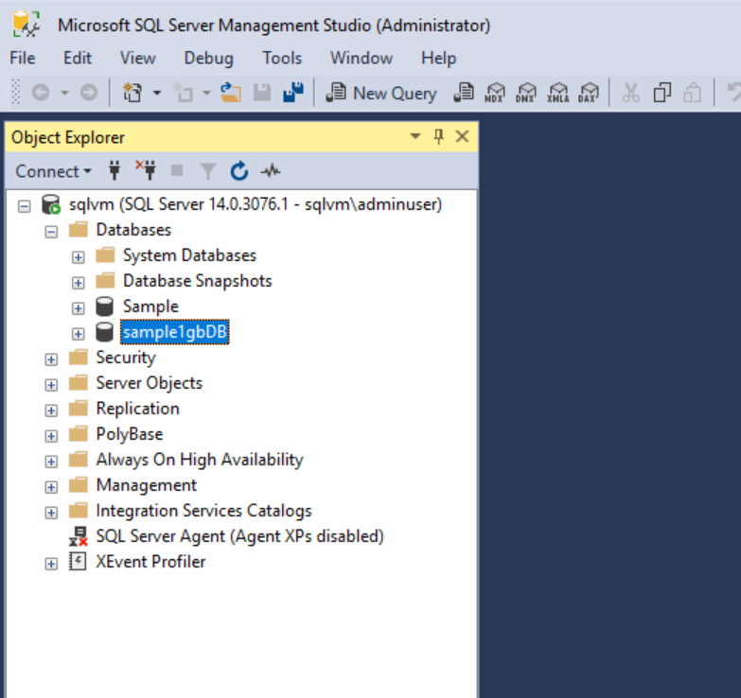

**Step3**

Install Microsoft Data Migration Assistant tool in source VM and Open

Select target server type as **sql server on azure virtual machines**

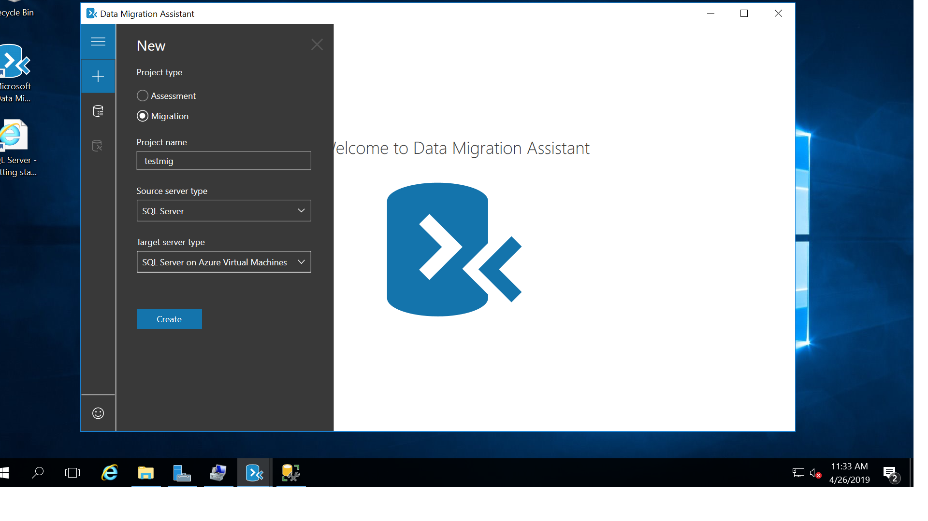

**Step4**

Fill the source and target VM’s details & click next

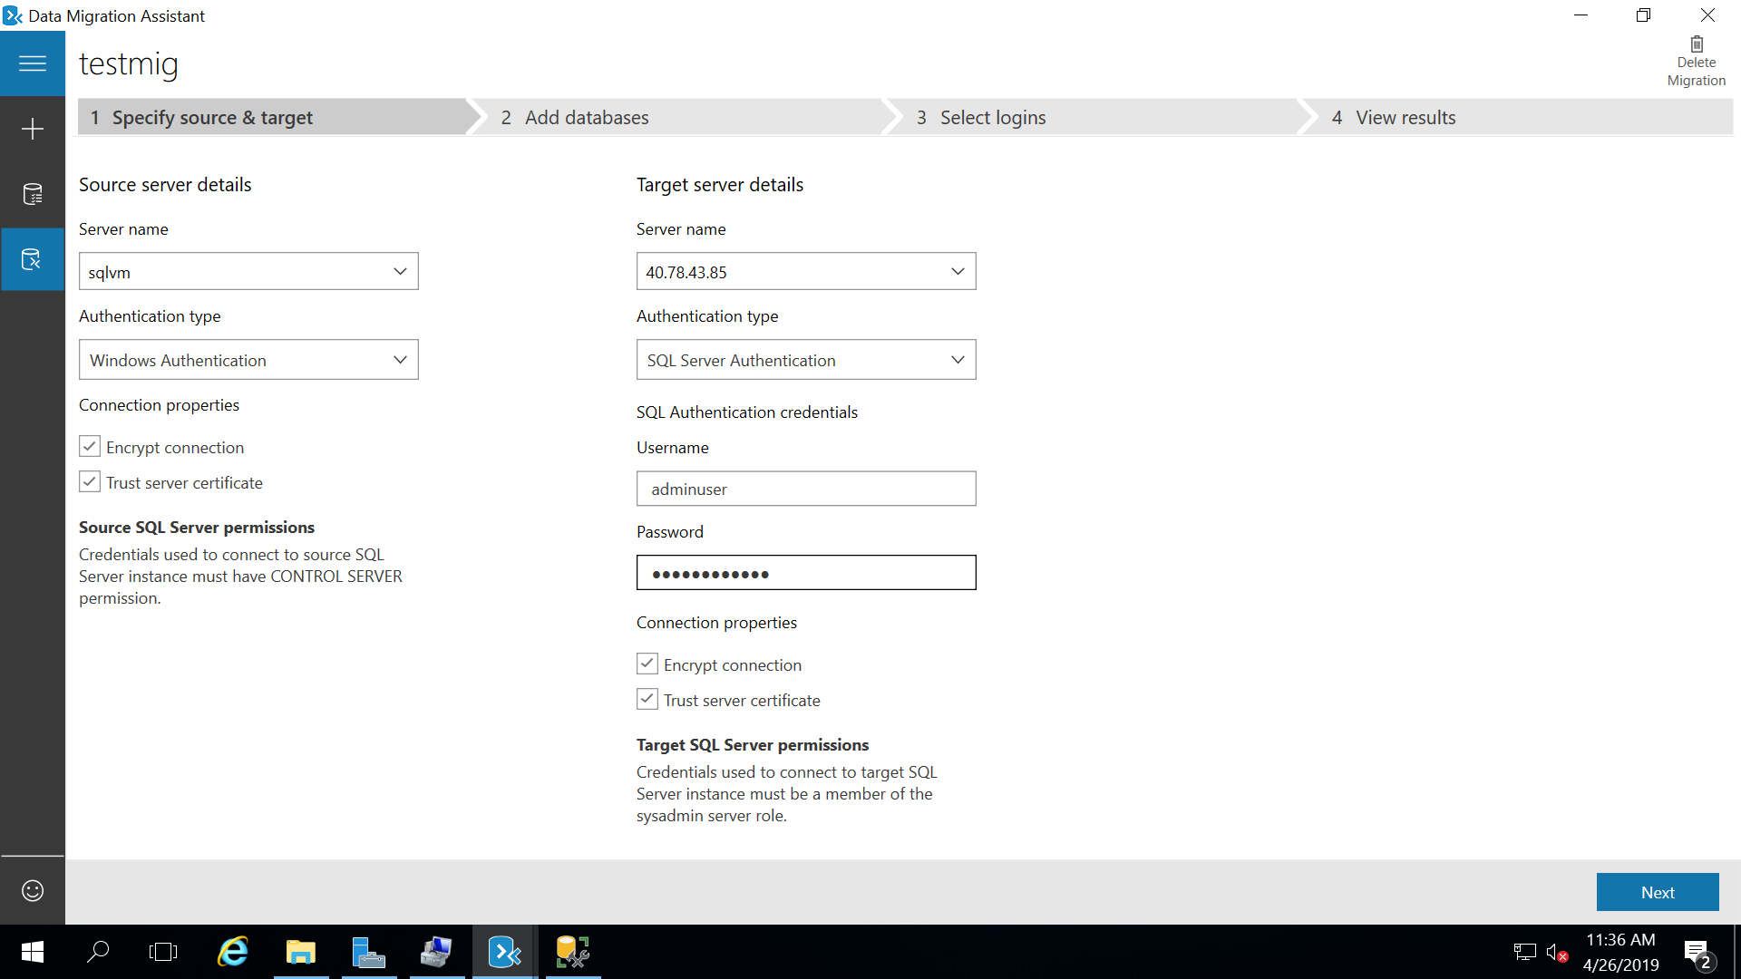

**Step5**

Select database from source and give the shared path

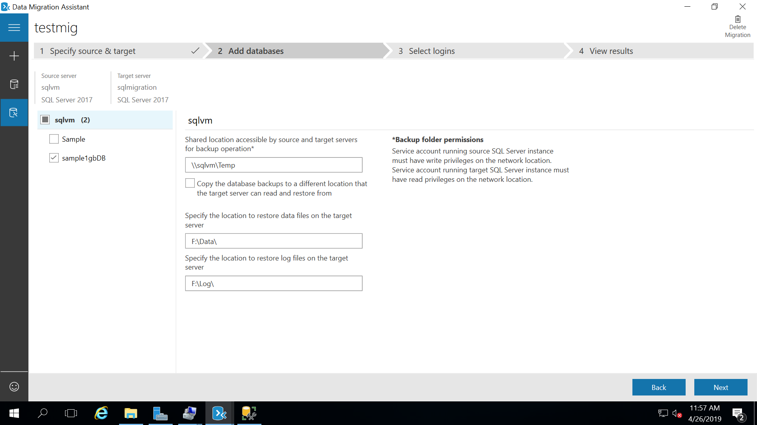

**Step6**

**Shared path creation details**

Go to IIS 🡪shared folders🡪 new share

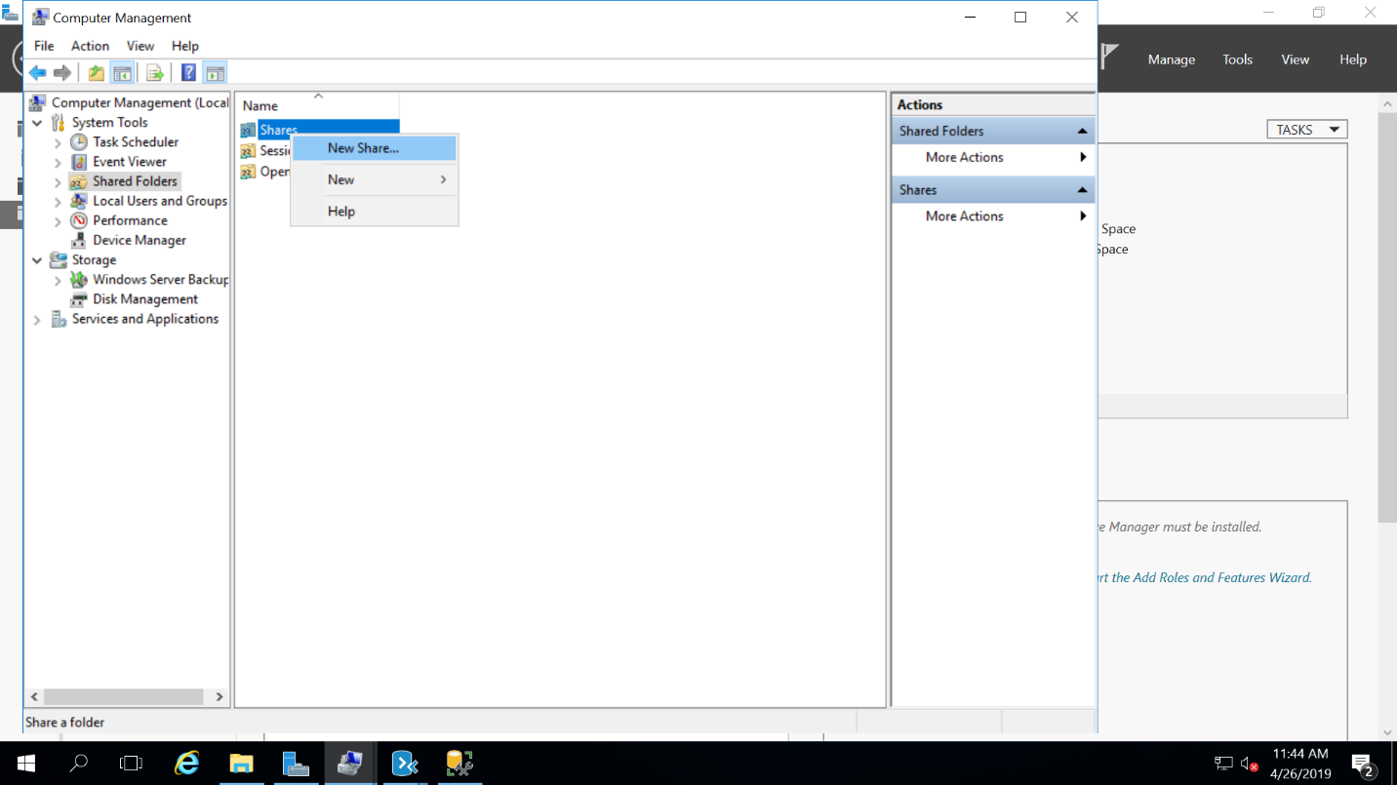

Browse folder where you want to store bak file while migration

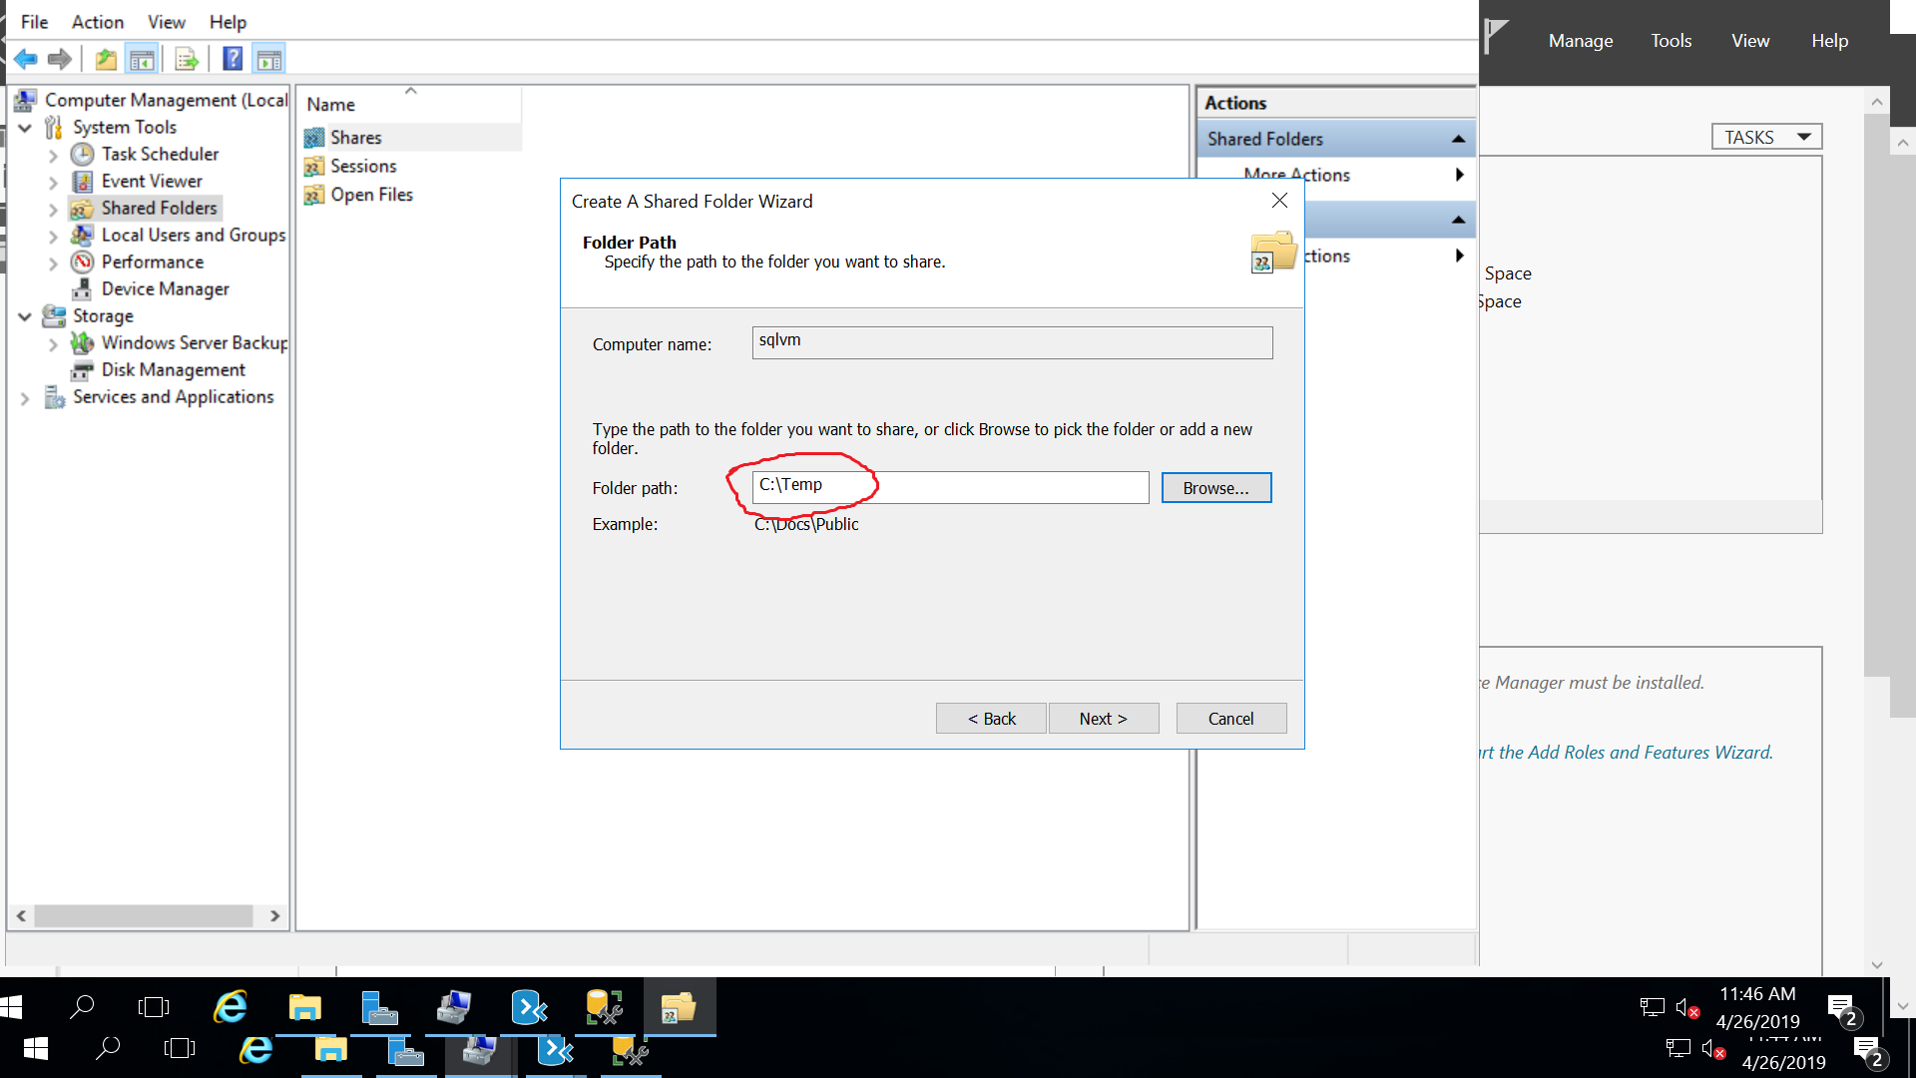

Once it’s done make sure that shared folder has read and write access to everyone

**Step7**

Go to target VM and open the sql server

Run the following sql query for access the shared folder from target

Exec xp_cmdshell 'net use Y: \\sqlvm\Temp Mindtree@123 /USER:adminuser /persistent:Yes'

xp_cmdshell 'dir Y:\'

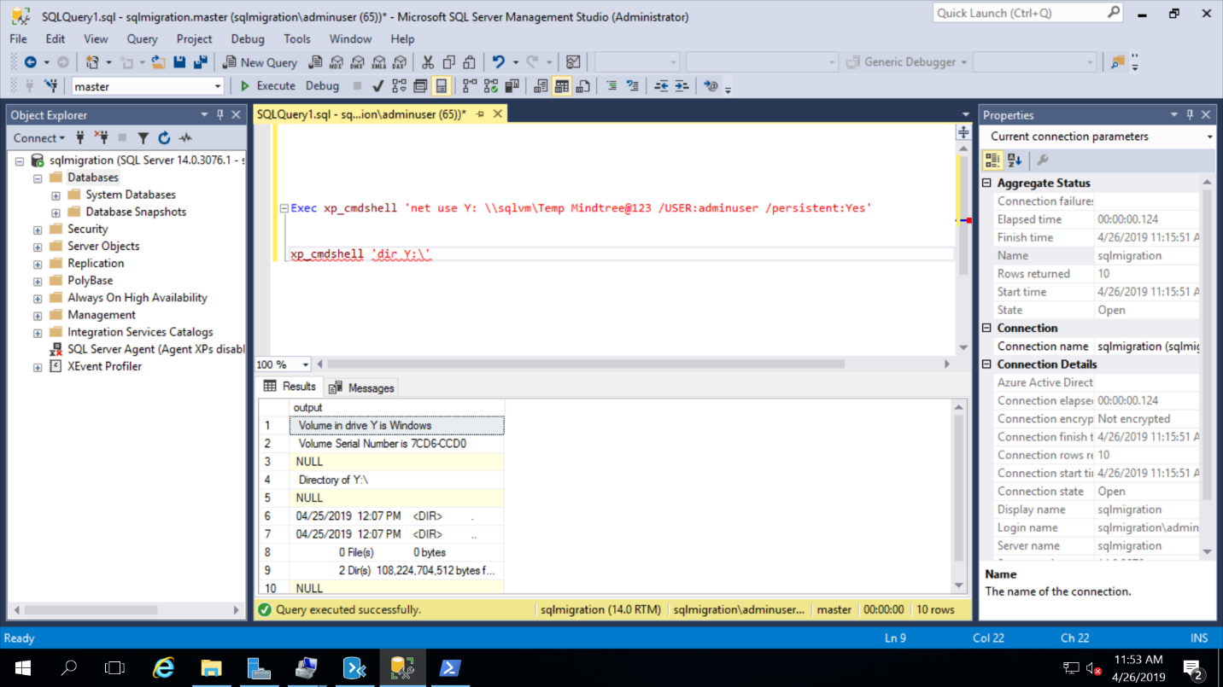

**Step8**

Click next from tool and choose login

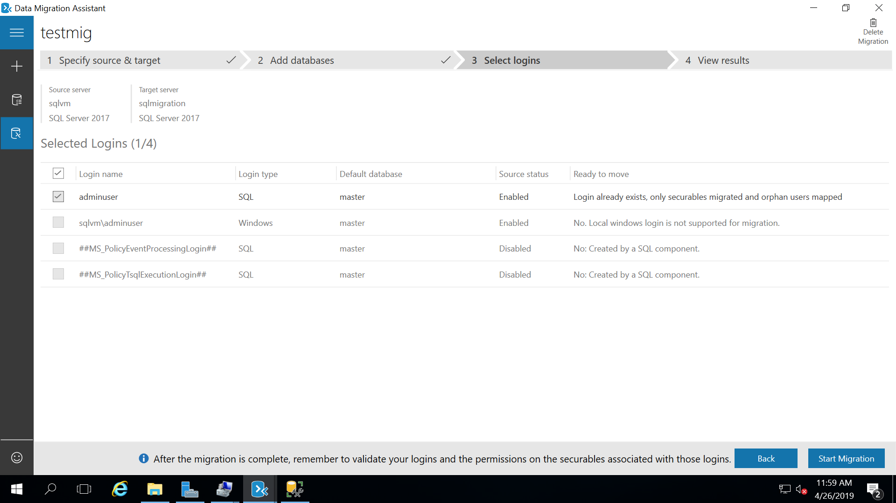

**Step9**

Click start migration

Once it is migrated screen will be

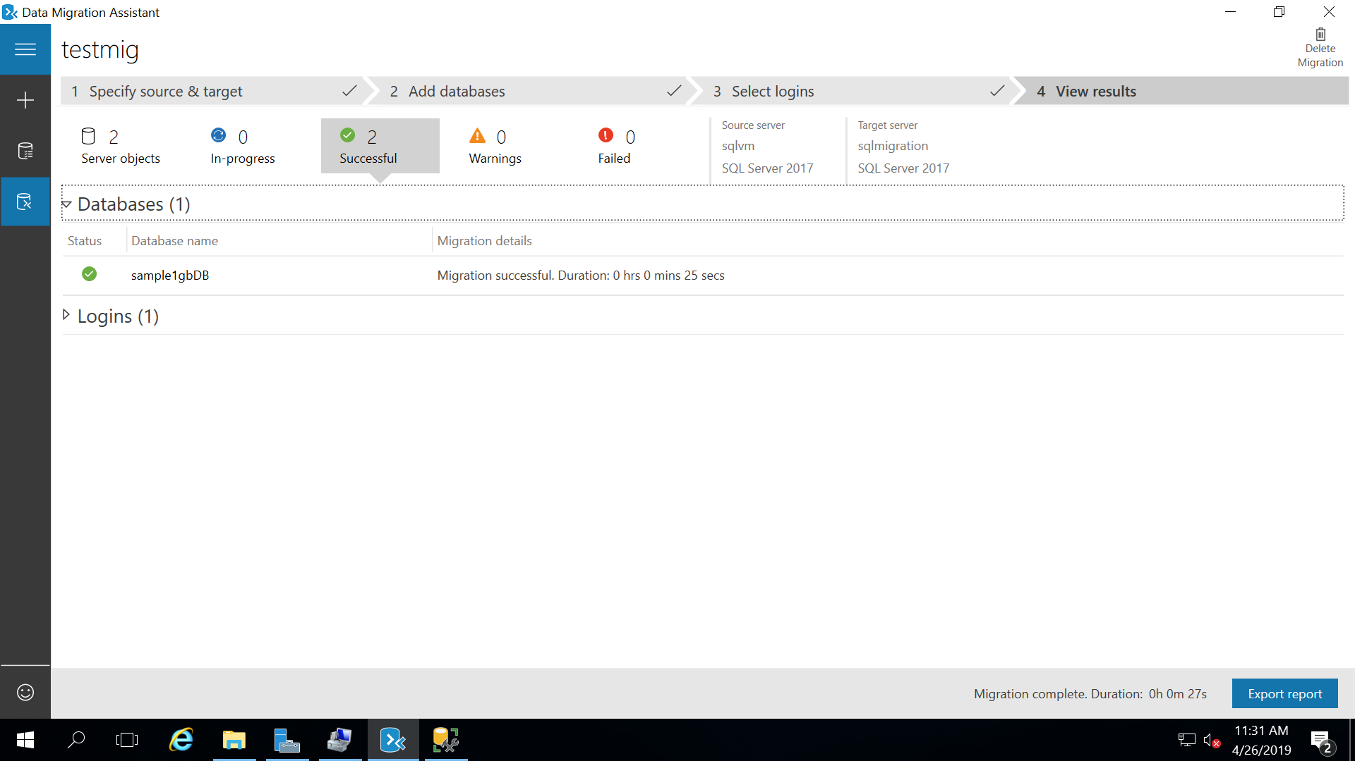

**Step10**

Go to target sql server and check the migrated database

